**Performing Net Present Value Analysis, Return on Investment, and Payback Analysis**

From Schwalbe, *Information Technology Project Management* Ed 7e, Chapter 4

Financial considerations are often an important aspect of the project selection process, especially during tough economic times.

Many organizations require an approved business case before pursuing projects,

and financial projections are a critical component of the business case. Three primary methods for projecting the financial value of projects include net present value analysis, return on investment, and payback analysis.

**Net Present Value Analysis**

Everyone knows that a dollar earned today is worth more than a dollar earned five years from now. Net present value (NPV) analysis is a method of calculating the expected net monetary gain or loss from a project by discounting all expected future cash inflows and outflows to the present point in time. An organization should consider only projects with a positive NPV if financial value is a key criterion for project selection. A positive NPV means that the return from a project exceeds the cost of capital—the return available by investing the capital elsewhere. Projects with higher NPVs are preferred to projects with lower NPVs, if all other factors are equal.

The example below illustrates this concept for two different projects. Note that this example starts discounting immediately in Year 1 and uses a 10 percent discount rate. You can use the NPV function in Microsoft Excel to calculate the NPV quickly. Detailed steps for performing this calculation manually are provided later. Note that the example lists the projected benefits first, followed by the costs, and then the calculated cash flow amount. Note that the sum of the cash flow - benefits minus costs or income minus expenses - is the same for both projects at $5,000. The net present values are different, however, because they account for the time value of money.

Project 1 has a negative cash flow of $5,000 in the first year, while Project 2 has a negative cash flow of only $1,000 in the first year. Although both projects have the same total cash flows without discounting, they are not of comparable financial value. Project 2’s NPV of $3,201 is better than Project 1’s NPV of $2,316. NPV analysis, therefore, is a method for making equal comparisons between cash flows for multi-year projects.

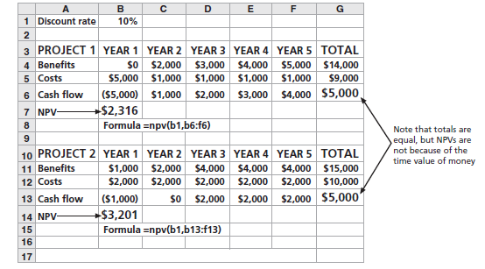

When calculating NPV, some organizations refer to the investment year or years for

project costs as Year 0, and do not discount costs in Year 0. Other organizations start discounting immediately based on their financial procedures; it’s simply a matter of preference for the organization. The discount rate can also vary, often based on the prime rate and other economic considerations. Financial experts in your organization can tell you what discount rate to use; some people consider it to be the rate at which you could borrow money for the project.

The next example shows another set of financial calculations.

Note that the discount rate is 8 percent, costs are not discounted right away (note the Year 0), the discount factors are rounded to two decimal places, costs are listed first, and costs are entered as positive numbers. The NPV and other calculations are the same; only the format is different. A project manager checks with the organization to learn its guidelines for when discounting starts, what discount rate to use, and what format the organization prefers.

To determine NPV, follow these steps:

1. Determine the estimated costs and benefits for the life of the project and the

products it creates. This example assumed its project would

produce a system in about six months that would be used for three years, so

costs are included in Year 0, when the system is developed, and ongoing

system costs and projected benefits are included for Years 1, 2, and 3.

2. Determine the discount rate, which is the rate used in discounting future

cash flow. It is also called the capitalization rate or opportunity cost of

capital.

3. Calculate the net present value. Most spreadsheet software has a built-in

function to calculate NPV. This example shows the formula that

Microsoft Excel uses:

=npv(discount rate, range of cash flows), where the discount

rate is in cell B1 and the range of cash flows for Project 1 are in cells

B6 through F6.

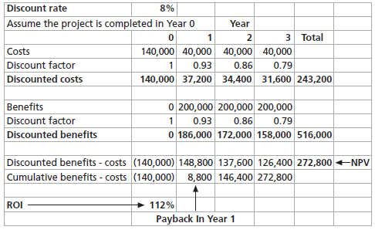

To use the NPV function, you must have a row or column in the spreadsheet for the cash flow each year, which is the benefit amount for that year minus the cost amount. The result of the formula yields an NPV of $2,316 for Project 1 and $3,201 for Project 2.

Because both projects have positive NPVs, they are good candidates for

selection. However, because Project 2 has an NPV that is 38 percent higher

than Project 1, it would be the better choice. If the two numbers are close,

then other methods should be used to help decide which project to select.

The mathematical formula for calculating NPV is:



where t equals the year of the cash flow, n is the last year of the cash flow, A is the

amount of cash flow each year, and r is the discount rate. If you cannot enter the data into spreadsheet software, you can perform the calculations by hand or with a calculator.

First, determine the annual discount factor - a multiplier for each year based on the discount rate and year—and then apply it to the costs and benefits for each year. The formula for the discount factor is 1/(1 + r)t where r is the discount rate, such as 8 percent, and t is the year. For example, the discount factors used in Figure 4-5 are calculated as follows:

Year 0: discount factor = 1/(1 + 0.08)0 = 1

Year 1: discount factor = 1/(1 + 0.08)1 = .93

Year 2: discount factor = 1/(1 + 0.08)2 = .86

Year 3: discount factor = 1/(1 + 0.08)3 = .79

After determining the discount factor each year, multiply the costs and benefits each

year by the appropriate discount factor. For example, the discounted cost for

Year 1 is $40,000 * .93 = $37,200. Next, sum all of the discounted costs and benefits each year to get a total. For example, the total discounted costs are $243,200. To

calculate the NPV, take the total discounted benefits and subtract the total discounted costs. In this example, the NPV is $516,000 - $243,200 = $272,800.

To aid in project selection, project managers must understand the organization’s

financial expectations for projects. Top management must also understand the limitations of financial estimates, particularly for IT projects. For example, it is very difficult to develop good estimates of projected costs and benefits for IT projects.